Ideation Phase

Define the Problem Statements

|  |  |
| --- | --- |
| Date | 15 Feb 2026 |
| Team ID | LTVIP2026TMIDS87011 |
| Project Name | Strategic Product Placement Analysis |
| Maximum Marks | 2 Marks |

**Customer Problem Statement :**

Retail companies, merchandising teams, and category managers face significant challenges in identifying which product placements drive higher sales, customer engagement, and profitability. Sales data is often stored in raw transactional formats, making it difficult to understand in-store buying behavior, product adjacency impact, seasonal demand patterns, and shelf performance across different store locations.

Without proper visual analytics tools, analyzing how product positioning influences purchasing decisions becomes inefficient and highly dependent on manual reporting. This lack of clear, centralized insight prevents decision-makers from optimizing shelf layouts, promotional placements, cross-selling strategies, and store-level merchandising performance.

There is a critical need to compare product performance across different time periods (for example, Year 1 vs Year 2 or Quarter-wise comparisons) to understand how placement strategies, promotional campaigns, and seasonal variations impact revenue and customer purchase patterns.

By developing an interactive visual analytics solution (using tools like Tableau or Power BI), stakeholders can:

Track sales performance by product category and shelf position

Identify high-performing placement zones (eye-level, end-cap, checkout, etc.)

Compare time-based trends (monthly, quarterly, yearly)

Analyze store-wise and region-wise product movement

Detect cross-selling and bundling opportunities

This interactive data storytelling approach transforms static retail sales data into actionable merchandising intelligence, enabling strategic decisions that directly improve revenue, customer experience, and operational efficiency.

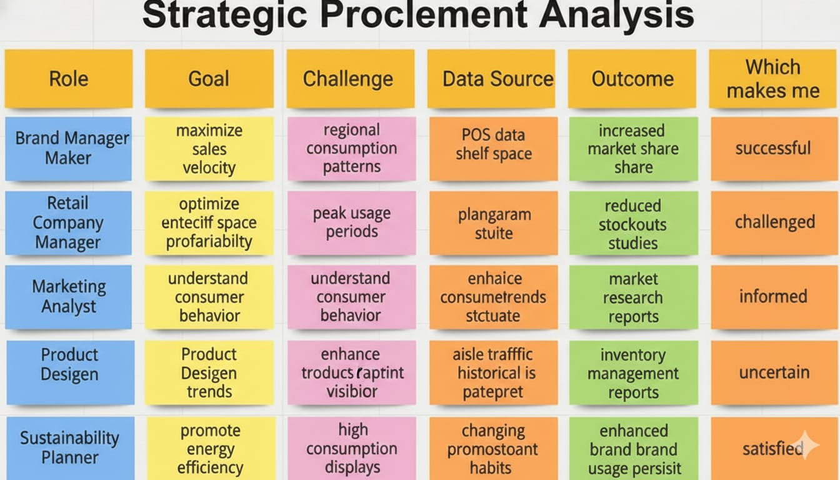

satisfiedd

| **PS ID** | **I am** | **I’m trying to** | **But** | **Because** | **Which makes me feel** |
| --- | --- | --- | --- | --- | --- |
| PS-1 | a retail merchandising manager | identify which product placements drive maximum sales and footfall | sales data is scattered across POS systems | there is no centralized placement analytics dashboard | uncertain about shelf optimization decisions |
| PS-2 | a category manager | compare product performance across stores, regions, and time periods | I can’t filter sales by placement zone and season accurately | reports are generic and not placement-focused | frustrated and unable to maximize category revenue |
| PS-3 | a retail operations executive | present placement performance insights to senior management | reports lack visual clarity and persuasive storytelling | dashboards are static and not interactive | ineffective during strategic review meetings |
| PS-4 | a marketing & promotions analyst | understand how placement, discounts, and seasonality affect product sales | I cannot easily analyze correlations between layout and revenue | existing tools don’t allow deep drill-down analysis | stuck and unable to recommend data-driven strategies |

Ideation Phase Empathize & Discover

|  |  |
| --- | --- |
| Date | 15 Feb 2026 |
| Team ID | LTVIP2026TMIDS87011 |
| Project Name | Strategic Product Placement Analysis |
| Maximum Marks | 4 Marks |

**Empathy Map Canvas:**

An empathy map is a simple, easy-to-digest visual that captures knowledge about a user’s behaviors and attitudes.

The primary user of the Strategic Product Placement Dashboard is a **retail merchandiser, category manager, or marketing analyst** who needs to monitor store-wide product performance, shelf-space efficiency, and sales fluctuations based on item location. The user often deals with massive rows of raw, unformatted point-of-sale (POS) and inventory data, lacking a centralized visual platform to analyze how product positioning impacts revenue or to clearly compare different store layouts and promotional periods.

Due to the absence of interactive and visual analytics, the user feels uncertain and overwhelmed while making shelf-allocation, cross-merchandising, and inventory decisions. They need a comprehensive, user-friendly Tableau dashboard with clear KPIs, sales trend analysis (such as conversion rates and seasonal spikes), and store-level or category filtering options. This will transform raw retail data into actionable insights for better operational and strategic decision-making regarding where products should be placed to maximize visibility and ROI.

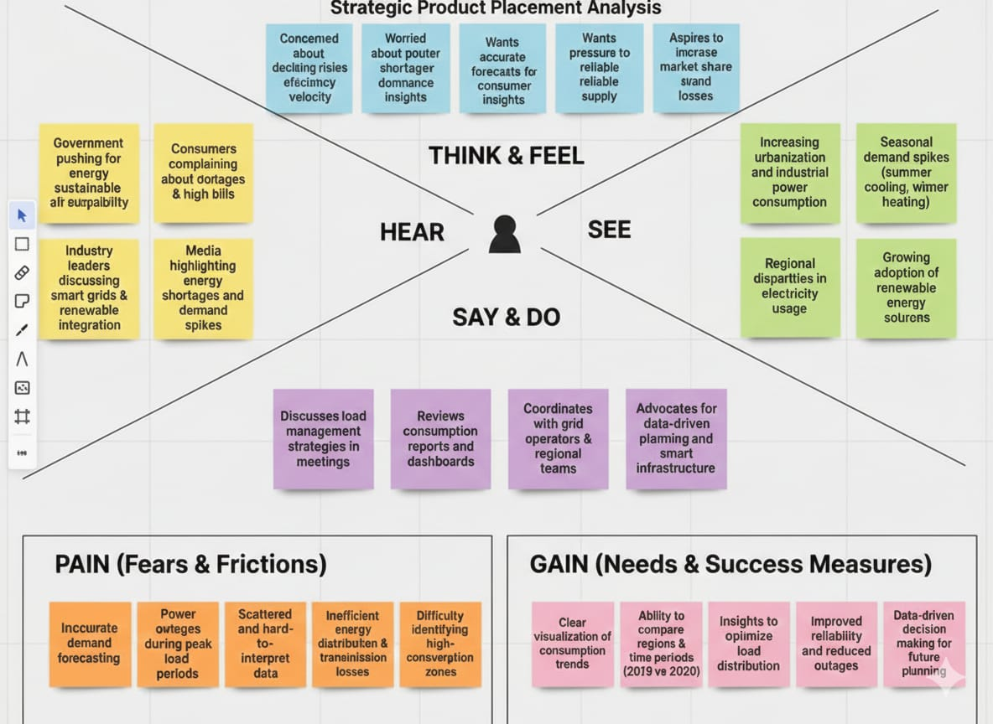

**Data -driven decision making for future planning**

**Project Design Phase-II**

**Data Flow Diagram & User Stories**

|  |  |
| --- | --- |
| Date | 16 February 2026 |
| Team ID | LTVIP2026TMIDS87011 |
| Project Name | Strategic Product Placement Analysis |
| Maximum Marks | 4 Marks |

**Data Flow Diagrams:**

A Data Flow Diagram (DFD) is a traditional visual representation of the information flows within a system. A neat and clear DFD can depict the right amount of the system requirement graphically. It shows how data enters and leaves the system, what changes the information, and where data is stored.

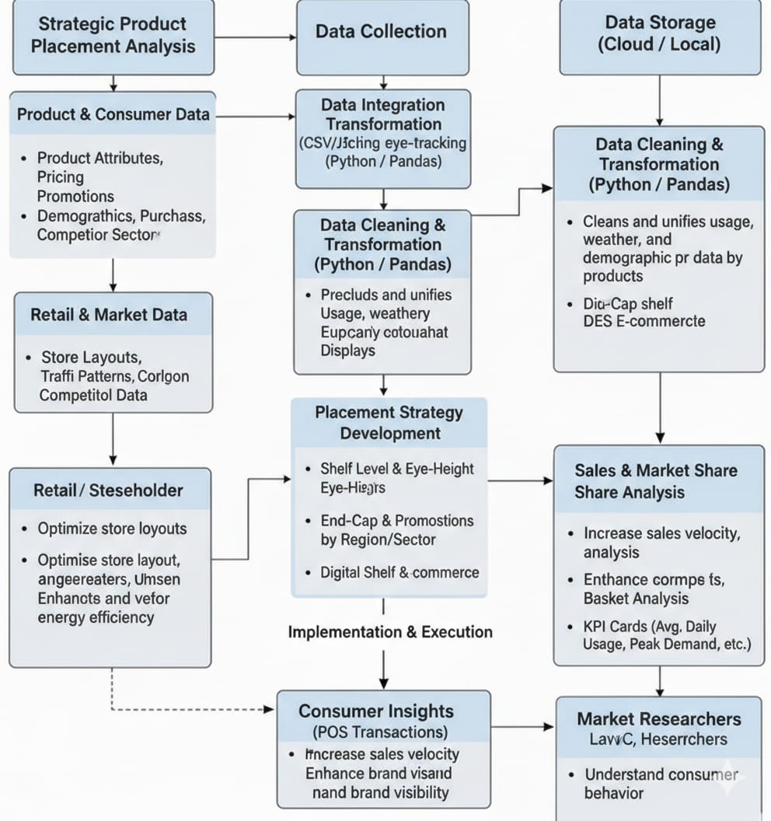

Understand Consumer behavior

**User Stories:**

Use the below template to list all the user stories for the product.

| **User Type** | **Functional Requirement (Epic)** | **User Story Number** | **User Story / Task** | **Acceptance Criteria** | **Priority** | **Release** |
| --- | --- | --- | --- | --- | --- | --- |
| Merchandising Analyst | Data Access & Integration | USN-1 | As a user, I can import retail sales and product placement data from CSV/Excel files or POS systems | Data loads successfully and is available for placement analysis | High | Sprint-1 |
| Data Analyst | Data Cleaning & Preparation | USN-2 | As a user, I can clean and standardize product categories, store locations, and placement zones | Dataset is structured, consistent, and free from duplicates or missing placement labels | High | Sprint-1 |
| Retail Manager | Dashboard Overview | USN-3 | As a user, I can view total sales, revenue, profit, and key placement KPIs | KPI cards display totals, growth %, and top-performing placement zones | High | Sprint-1 |
| Category Manager | Placement Zone Analysis | USN-4 | As a user, I can compare product performance by shelf position (eye-level, end-cap, checkout, aisle) | Placement-wise visualizations update accurately and reflect correct sales contribution | High | Sprint-1 |
| Regional Manager | Store & Regional Analysis | USN-5 | As a user, I can compare product placement performance across stores and regions | Store-wise and region-wise charts reflect accurate comparative data | High | Sprint-1 |
| Marketing Analyst | Time-Based Trends | USN-6 | As a user, I can analyze monthly, quarterly, and seasonal sales trends by placement | Trend charts display correct time-based variations and seasonal impact | High | Sprint-1 |
| Operations Executive | Filters & Interaction | USN-7 | As a user, I can filter data by store, category, time period, and placement zone | Dashboard updates dynamically based on selected filters | High | Sprint-2 |
| Sales Strategist | Performance Insights | USN-8 | As a user, I can identify underperforming and high-performing placement zones | High- and low-performing zones are clearly highlighted using visual indicators | Medium | Sprint-2 |
| Senior Executive | Story & Reporting | USN-9 | As a user, I can view story-driven insights for management presentations | Dashboard story view presents key insights with captions and summary analysis | Medium | Sprint-2 |
| System Administrator | Dashboard Publishing & Sharing | USN-10 | As an admin, I can publish dashboards to Tableau Server/Power BI Service for stakeholder access | Dashboard is securely accessible with appropriate role-based permissions | Medium | Sprint-2 |

Project Design Phase-II

Solution Requirements (Functional & Non-functional)

|  |  |
| --- | --- |
| Date | 16 February 2026 |
| Team ID | LTVIP2026TMIDS87011 |
| Project Name | Strategic Product Placement Analysis |
| Maximum Marks | 4 Marks |

# Functional Requirements:

Following are the functional requirements of the proposed solution.

| **FR No.** | **Functional Requirement (Epic)** | **Sub Requirement (Story / Sub-Task)** |
| --- | --- | --- |
| **FR-1** | **Data Integration & Preparation** | • Connect Tableau/BI tool to retail sales and product placement dataset(s). • Clean and format data (handle missing values, standardize product categories, placement zones, store names, and date formats). • Create calculated fields (e.g., Year-over-Year growth, placement contribution %, profit margin, basket size metrics). |
| **FR-2** | **Core Visualizations Development** | • Build time-based trend charts (monthly, quarterly, yearly sales performance). • Develop store-wise and region-wise comparison charts. • Create placement zone analysis visuals (e.g., bar charts comparing eye-level, end-cap, checkout sales). • Design category-wise contribution charts (bar/pie/stacked charts). |
| **FR-3** | **Dashboard Interactivity & User Controls** | • Implement global time filters (date range, quarter, year). • Add filters for store, region, product category, and placement zone. • Enable interactive tooltips showing sales, revenue, and profit metrics. • Allow drill-down from region → store → product category → individual product. |
| **FR-4** | **Dashboard Storytelling & Deployment** | • Combine visualizations into a cohesive Strategic Product Placement Dashboard. • Publish dashboard to Tableau Server/Cloud/Public. • Enable export functionality (PDF, image, or Excel summary). |
| **FR-5** | **Comparative & Placement Performance Analysis** | • Provide Year-over-Year (YoY) and Period-over-Period comparison. • Generate placement heat maps to highlight high-performing and underperforming shelf zones. • Compare promotional vs non-promotional placement performance. |
| **FR-6** | **Trend & Insight Detection** | • Identify peak sales periods and seasonal demand patterns. • Implement visual indicators (reference lines, color coding) to highlight unusually high or low placement performance. • Detect underperforming placement zones for optimization recommendations. |

# Non-functional Requirements:

Following are the non-functional requirements of the proposed solution.

| **NFR No.** | **Non-Functional Requirement** | **Description** |
| --- | --- | --- |
| **NFR-1** | **Usability** | The dashboard must be intuitive, clean, and easy to navigate. It should use consistent color coding for placement performance levels, readable fonts, and simple filters so non-technical retail managers can easily interpret insights. |
| **NFR-2** | **Security** | If deployed internally, role-based access control (RBAC) or Row-Level Security (RLS) must restrict store-level or sensitive sales data. If published publicly, the raw dataset should be protected from download where possible. |
| **NFR-3** | **Reliability** | All visualizations must accurately reflect the underlying retail dataset. Scheduled data refreshes must complete successfully without causing inconsistencies or data corruption. |
| **NFR-4** | **Performance** | The dashboard should load within 3–5 seconds under normal data volumes. Filters, drill-downs, and interactions should update dynamically without noticeable lag. |
| **NFR-5** | **Availability** | The dashboard must be accessible 24/7 via Tableau Server, Tableau Cloud, or other BI platforms to support continuous retail monitoring. |
| **NFR-6** | **Scalability** | The data model should support future expansion (e.g., adding more stores, new placement zones, additional years of sales data) without requiring a full redesign or performance degradation. |

**Project Design Phase-II**

**Technology Stack (Architecture & Stack)**

|  |  |
| --- | --- |
| Date | 16 February 2026 |
| Team ID | LTVIP2026TMIDS87011 |
| Project Name | Strategic Product Placement Analysis |
| Maximum Marks | 4 Marks |

**Technical Architecture:**

The Deliverable shall include the architectural diagram as below and the information as per the table1 & table 2

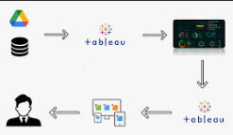

**Technology Stack**

Below is the technology stack used in the iRevolution Tableau project.

**Table-1**: System Component

| **Sno** | **Components** | **Description** | **Technology** |
| --- | --- | --- | --- |
| 1 | User Interface | How users interact with the Strategic Product Placement analytics platform (Web Dashboard, Mobile-responsive view, etc.) | HTML, CSS, JavaScript / Angular JS / React JS |
| 2 | Data Integration Layer | Connects and imports retail sales, product placement, POS, and inventory datasets from files or databases | Python, Tableau |
| 3 | Data Preparation & Transformation | Cleans, formats, and prepares raw retail data for analysis (handling null values, standardizing product categories, placement zones, store names, and date formats) | Tableau Prep, Python (Pandas, NumPy) |
| 4 | Analytics & Visualization Engine | Creates charts, heat maps, placement comparison dashboards, and trend visualizations to analyze product placement performance | Tableau Desktop |
| 5 | Calculated Metrics & Business Logic | Computes KPIs such as Placement Contribution %, Year-over-Year Sales Growth, Profit Margins, Basket Size, and Placement Effectiveness Index | Tableau Calculated Fields, Python |
| 6 | Database | Stores structured retail sales, placement, and transaction datasets along with processed data extracts | MySQL / PostgreSQL / CSV Data Sources |
| 7 | Cloud & File Storage | Stores datasets, dashboard files, and backup assets for sharing and collaboration | Google Drive / AWS S3 / Local Storage |
| 8 | Dashboard Publishing Platform | Publishes dashboards for access by retail managers, executives, and stakeholders | Tableau Public / Tableau Server / Tableau Cloud |
| 9 | External Data Sources | Integrates supplementary datasets such as customer demographics, promotional campaign data, seasonal calendars, or footfall metrics | Open Data APIs / CSV datasets |
| 10 | Performance Optimization | Improves dashboard loading speed, responsiveness, and data refresh performance | Tableau Extracts (.hyper), Data Aggregation, Indexing |
| 11 | Infrastructure & Deployment | Hosts dashboards for stakeholder access and ensures continuous availability and reliability | Local Server / Cloud Hosting |

**Table-2:** Application Characteristics:

| **S.No** | **Category** | **Description** | **Technology Used** |
| --- | --- | --- | --- |
| 1 | Open-Source Frameworks | Libraries used for retail data cleaning, transformation, analysis, and predictive modeling of product placement performance | Python, Pandas, NumPy, Scikit-Learn |
| 2 | Security Implementations | Access control and authentication mechanisms to ensure only authorized users can view store-level and sales-sensitive dashboards | Role-Based Access Control (RBAC), OAuth 2.0 |
| 3 | Scalable Architecture | System design supports addition of new stores, product categories, placement zones, and future years of sales data without redesign | Cloud Storage, REST APIs |
| 4 | Availability | Ensures the dashboard is accessible during executive meetings, store reviews, and merchandising planning sessions | Tableau Server Deployment / Tableau Cloud Hosting |
| 5 | Performance | Optimized data extracts, aggregations, and filtering mechanisms to ensure fast dashboard loading and smooth interactivity | Tableau Extracts (.hyper), Indexed Queries |
| 6 | Data Accuracy | Validation of KPIs (sales, profit margins, placement contribution %, YoY growth) against raw retail datasets before publishing | Data Validation Scripts (Python) |
| 7 | Usability | Clean dashboard layout with clear legends, consistent color coding for placement zones, and intuitive filter controls for non-technical retail users | Tableau Design Principles |
| 8 | Reliability | Handles missing sales records, incomplete placement tags, or inconsistent store data without calculation errors or dashboard crashes | Error Handling in Python, Data Cleaning Logic |

**Project Design Phase-II**

**Data Flow Diagram & User Stories**

|  |  |
| --- | --- |
| Date | 16 February 2026 |
| Team ID | LTVIP2026TMIDS87011 |
| Project Name | Strategic Product Placement Analysis |
| Maximum Marks | 4 Marks |

**Customer Journey Map:**

This map represents how a retail merchandising manager or product strategist interacts with the **Strategic Product Placement Dashboard** from identifying a business need to gaining actionable insights

| **Dimension** | **Entice** | **Enter** | **Engage** | **Exit** | **Extend** |
| --- | --- | --- | --- | --- | --- |
| **Steps** | Management identifies declining sales or uneven product performance and recommends using the Strategic Product Placement Dashboard to analyze placement effectiveness. | User logs into Tableau Server/Power BI Service, navigates to the retail analytics workspace, and opens the “Strategic Product Placement Analysis” dashboard. | User filters data by store, product category, placement zone (eye-level, end-cap, checkout), and time period. They drill down into sales trends to identify high-performing and underperforming placement areas. | User exports a performance summary (PDF/Excel) and shares insights with store managers and marketing teams along with placement optimization recommendations. | User sets up automated alerts to track weekly sales changes by placement zone and monitors performance continuously for future layout decisions. |
| **Interactions** | • People: Store Head, Sales Director • Places: Office/Regional HQ  • Things: Sales reports, Revenue summaries | • Places: Web browser • Things: Tableau/BI login portal, SSO authentication | • Things: Interactive dashboard, filters, drill-down charts, heatmaps, trend lines | • People: Store Managers, Marketing Team  • Things: Export tools, Email, Presentation slides | • Things: Automated alerts, KPI notifications, Team collaboration tools (Slack/Teams) |
| **Goals & Motivation** | Help me understand why certain products are underperforming despite high footfall. | Help me access placement and sales data quickly and securely without technical complexity. | Help me clearly identify which shelf positions and promotional zones generate maximum sales and profit. | Help me present clear, data-backed recommendations to improve store layout and product visibility. | Help me continuously monitor placement performance without manually checking reports every day. |
| **Positive Moments** | Relief knowing there is a centralized dashboard instead of relying on scattered Excel sheets. | Smooth login experience and fast dashboard loading. | Clear visual identification of high-performing zones (e.g., end-cap displays boosting impulse purchases). | One-click export generates a clean, presentation-ready report. | Automated alerts confirm when placement improvements lead to measurable sales growth. |
| **Negative Moments** | Pressure from management to quickly justify declining category sales. | Slow loading due to heavy transaction-level data. | Dashboard feels cluttered or filters are confusing. Data not updated in real-time. | Export formatting issues or missing visual elements in static reports. | Too many alerts causing notification fatigue or irrelevant triggers. |
| **Areas of Opportunity** | Embed dashboard access link in weekly sales performance emails for easy discovery. | Optimize dashboard using aggregated datasets and scheduled refreshes. | Add predictive analytics to forecast placement impact and highlight underperforming zones automatically. | Create a dedicated “Executive Summary View” optimized for PDF export and board presentations. | Integrate alerts directly with Slack/Microsoft Teams channels for real-time collaboration and faster decision-making. |

**Project Design Phase-I**

**Problem – Solution Fit**

|  |  |
| --- | --- |
| Date | 16 February 2026 |
| Team ID | LTVIP2026TMIDS87011 |
| Project Name | Strategic Product Placement Analysis |
| Maximum Marks | 2 Marks |

**Problem – Solution Fit**

**Strategic Product Placement Analysis Using Tableau**

Identifying a real problem faced by users and ensuring that the developed solution effectively addresses it. In the context of this project, stakeholders struggle to understand the direct impact of product location on sales and customer behavior using raw, scattered point-of-sale (POS) and inventory data. The Tableau-based analytics solution transforms complex retail datasets into clear, interactive visual insights, enabling informed, data-backed decision-making for merchandising and store layouts.

**Purpose**

**Solve complex retail data challenges:** The project converts unstructured sales, inventory, and store layout data into interactive dashboards. This helps category managers, retail merchandisers, and marketers easily identify high-performing shelf zones, cross-selling opportunities, and product category trends.

**Improve adoption through familiar tools and behavior:** By using Tableau dashboards accessible via web platforms, users can explore retail data through intuitive filters, heat maps, and drill-down features without needing advanced technical data science skills.

**Strengthen communication and decision-making:** Clear visualizations support effective reporting and communication of product performance metrics, enabling better shelf-space allocation, promotional planning, and visual merchandising strategies across different departments.

**Increase engagement and trust:** By addressing recurring issues such as poor shelf space utilization, stagnant inventory, and missed cross-merchandising opportunities, the solution builds trust and encourages continuous use by delivering measurable ROI on floor planning.

**Understand and optimize the current retail landscape:** The project provides insights into store-wise performance, seasonal promotional impacts, and category-level sales spikes, helping stakeholders optimize product visibility, layout efficiency, and overall revenue generation.

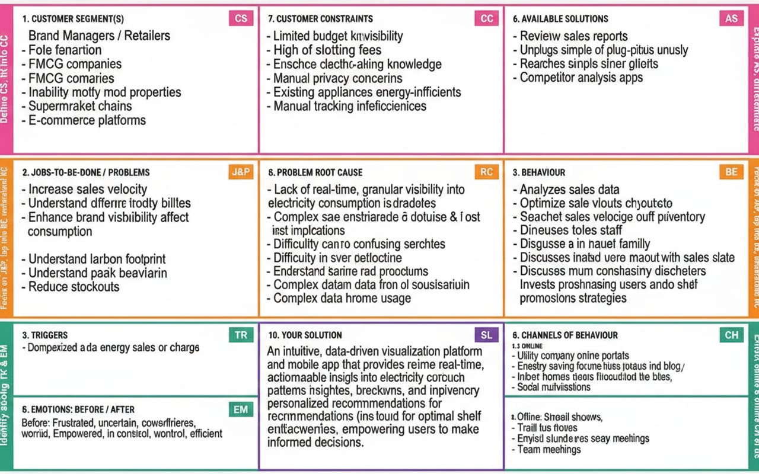

**Project Design Phase-I**

**Proposed Solution**

|  |  |
| --- | --- |
| Date | 16 February 2026 |
| Team ID | LTVIP2026TMIDS87011 |
| Project Name | Strategic Product Placement Analysis |
| Maximum Marks | 2 Marks |

**Proposed Solution:**

| **S.No.** | **Parameter** | **Description** |
| --- | --- | --- |
| **1.** | **Problem Statement (Problem to be solved)** | Retailers, category managers, and visual merchandisers lack a centralized, data-driven platform to monitor how product placement impacts sales, category performance, and overall store profitability. Point-of-Sale (POS) and inventory data are often scattered across raw files and spreadsheets, leading to slow analysis, inefficient floor planning, and missed revenue opportunities. |
| **2.** | **Idea / Solution description** | The Strategic Product Placement Dashboard is an interactive Tableau-based solution that integrates sales data, store layout metrics, promotional periods, and customer purchasing patterns into a unified visualization platform. It enables layout optimization, cross-selling analysis, and shelf-space efficiency tracking through interactive filters and drill-down features. |
| **3.** | **Novelty / Uniqueness** | • Combines store layout performance, category-level sales trends, and shelf-space ROI in one dashboard.  • Enables A/B testing comparisons of different product placements (e.g., end-cap vs. middle aisle or pre- vs. post-promotion).  • Uses story-based visualizations for merchandising strategy presentations and floor planning.  • Simplifies complex POS and inventory datasets into intuitive heat maps and charts for quick insights. |
| **4.** | **Social Impact / Customer Satisfaction** | • Enhances the customer shopping experience by making high-demand products more accessible and logically grouped.  • Supports efficient inventory management, which can reduce dead stock and product expiration/waste.  • Helps brick-and-mortar retailers maximize floor space utility and improve operating margins.  • Fosters better data-driven collaboration between marketing, sales, and inventory teams. |
| **5.** | **Business Model (Revenue Model)** | • B2B SaaS subscription model targeted at retail chains, FMCG brands, supermarkets, and large department stores.  • Revenue generated from customized dashboard deployment, premium analytics modules, and integration with existing POS/ERP systems.  • Value-added consulting services for retail space optimization and visual merchandising strategies. |
| **6.** | **Scalability of the Solution** | Built on scalable BI and cloud-enabled infrastructure, the solution can easily integrate real-time POS feeds, RFID inventory trackers, and in-store foot-traffic sensors (like heat-mapping cameras). It can expand from single-store analysis to supporting multi-national retail chains, franchise benchmarking, and AI-driven predictive merchandising. |

**Project Design Phase-I**

**Solution Architecture**

|  |  |
| --- | --- |
| Date | 16 February 2026 |
| Team ID | LTVIP2026TMIDS87011 |
| Project Name | Strategic Product Placement Analysis |
| Maximum Marks | 4 Marks |

**Solution Architecture:**

**Strategic Product Placement Analysis Using Tableau**

The platform follows a layered system architecture designed to efficiently collect, process, analyze, and visualize retail sales and product placement data to support data-driven merchandising decisions.

**1. Data Providers & Sources**

**Sources:**

Point of Sale (POS) Systems

Inventory Management Systems

Store Layout & Planogram Data

Promotional Campaign Records

Customer Transaction Logs

**Data Generated:**

* Product-wise sales transactions
* Store and region performance data
* Shelf placement information (eye-level, end-cap, checkout, aisle)
* Discount and promotional data
* Time-based sales records (daily, monthly, seasonal)

**2. Data Ingestion Layer**

**Methods:**

CSV/Excel uploads from retail branches

Direct database connections (MySQL/PostgreSQL)

API integrations from POS systems

Scheduled automated data imports

This layer ensures consistent and structured data collection from multiple retail sources.

**3. Raw Data Storage Layer**

**Infrastructure:**

Cloud storage (AWS S3, Google Cloud Storage)

Local server storage

Centralized data repository

**Purpose:**

Maintains historical retail sales and placement data for long-term performance tracking and comparative analysis.

**4. Data Processing & Transformation Layer (ETL)**

**Tools:**

Python (Pandas, NumPy)

Tableau Prep

**Actions:**

Remove missing or duplicate transaction records

Standardize product categories, store names, and placement zones

Format date/time fields for time-based analysis

Aggregate data by store, region, category, and placement zone

Generate calculated metrics such as YoY growth, placement contribution %, and profit margins

This layer transforms raw retail data into analytics-ready datasets.

**5. Data Storage & Query Layer**

**Technologies:**

MySQL / PostgreSQL

Cloud-based data warehouse

**Purpose:**

Stores cleaned and structured data optimized for fast queries, interactive filtering, and scalable retail analytics.

**6. Analytics & Visualization Layer**

**Tools:**

Tableau Desktop

Tableau Server / Tableau Cloud / Tableau Public

**Outputs:**

Interactive dashboards showcasing:

* Store-wise and region-wise sales comparisons
* Placement zone performance analysis
* Monthly, quarterly, and seasonal trends
* High-performing vs underperforming shelf areas
* Key KPIs (Total Sales, Profit Margin, Placement Effectiveness Index, YoY Growth)

This layer converts structured data into actionable business insights.

**7. Monitoring & Alerts Layer (Optional)**

**Features:**

Threshold-based alerts for sudden drop/increase in sales by placement zone

Automated weekly or monthly performance reports

Email/Slack/Teams notifications for merchandising teams

This enables proactive retail decision-making and faster corrective action.

**8. End Users & Stakeholders**

**Audience:**

* Retail Managers
* Merchandising Teams
* Category Managers
* Marketing & Promotions Analysts
* Senior Executives

**Outcomes:**

Optimized shelf space allocation

Improved product visibility and sales performance

Data-driven promotional strategies

Better store layout planning

Increased revenue and profitability

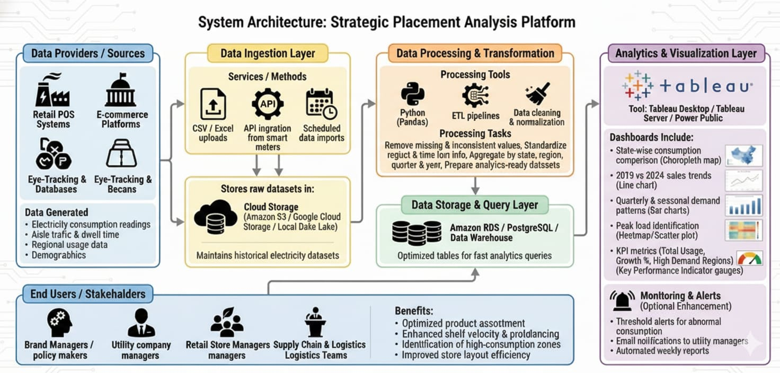

Project Planning Phase

**Project Planning Template (Product Backlog, Sprint Planning, Stories, Story points)**

|  |  |
| --- | --- |
| Date | 17 February 2026 |
| Team ID | LTVIP2026TMIDS87011 |
| Project Name | Strategic Product Placement Analysis |
| Maximum Marks | 5 Marks |

Product Backlog, Sprint Schedule, and Estimation (4 Marks)

|  |  |  |  |  |  |  |
| --- | --- | --- | --- | --- | --- | --- |
| **Sprint** | **Functional Requirement (Epic)** | **User Story Number** | **User Story / Task** | **Story Points** | **Priority** | **Team Members** |
| Sprint-1 | Data Collection | USN-1 | As a user, I can load data into the processing environment | 1 | High | ALL |
| Sprint-2 | Data Preprocessing | USN-2 | As a user, I can handle missing values in the dataset | 3 | Medium | ALL |
| Sprint-2 | Data Preprocessing | USN-3 | As a user, I can encode or map categorical variables appropriately | 2 | Medium | ALL |
| Sprint-3 | Making Graphs/Visualizations | USN-4 | As a user, I can build the initial model based on processed data | 5 | High | ALL |
| Sprint - 4 | Dashboard &  STORIES | USN – 5 | Dark ui with eye feasted color palette | 6 | HIGH | ALL |
| Sprint - 5 | Report & documentation | USN – 6 | The step by step guide documentation | 7 | MEDIUM | ALL |

Project Tracker, Velocity & Burndown Chart: (4 Marks)

|  |  |  |  |  |  |  |
| --- | --- | --- | --- | --- | --- | --- |
| **Sprint** | **Total Story Points** | **Duration** | **Sprint Start Date** | **Sprint End Date (Planned)** | **Story Points Completed (as on Planned End Date)** | **Sprint Release Date (Actual)** |
| Sprint-1 | 20 | 1 Day | 5 Feb 2026 | 5 Feb 2026 | 20 | 5 Feb 2026 |
| Sprint-2 | 20 | 2 Day | 6 Feb 2026 | 7 Feb 2026 | 20 | 7 Feb 2026 |
| Sprint-3 | 20 | 2 Day | 9 Feb 2026 | 10 Feb 2025 | 20 | 10 Feb 2026 |
| Sprint-4 | 20 | 2 Day | 11 Feb 2026 | 12 Feb 2026 | 20 | 12 Feb 2026 |
| Sprint-5 | 20 | 3 Day | 15 Feb 2026 | 17 Feb 2026 | 20 | 17 Feb 2026 |

PRODUCT PLACEMENT ANALYSIS DASHBOARD

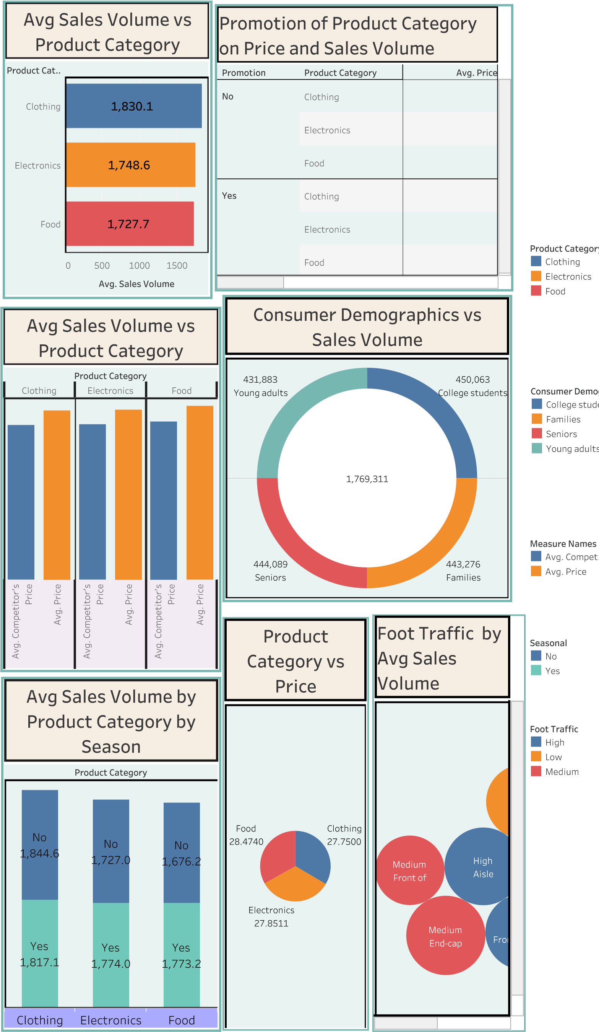

1.Avg Sales Volume vs Product Category:

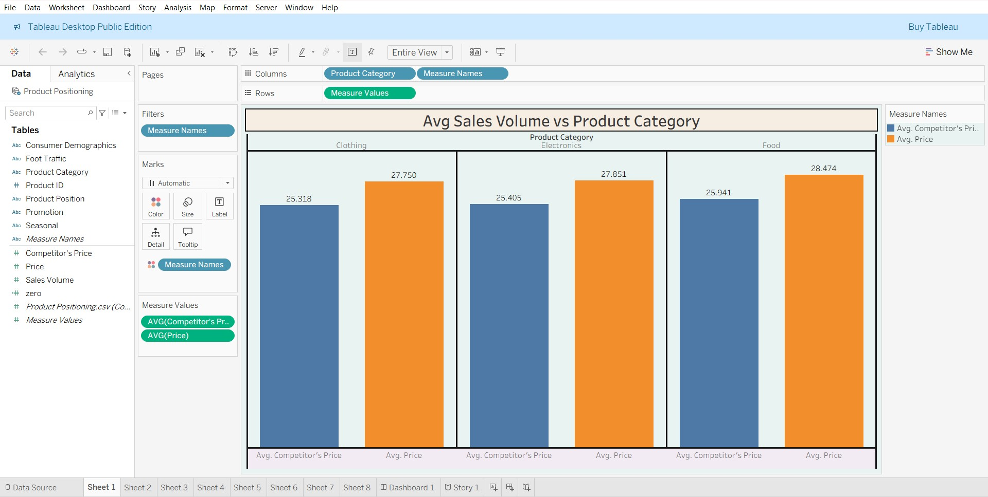

2.Avg Sales Volume vs Product Category:

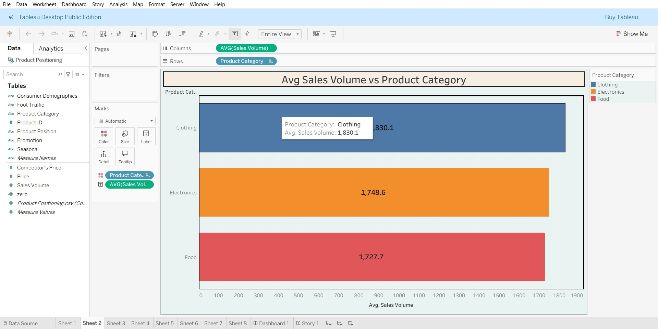

3.Avg Sales Volume by Product Category by Product Position:

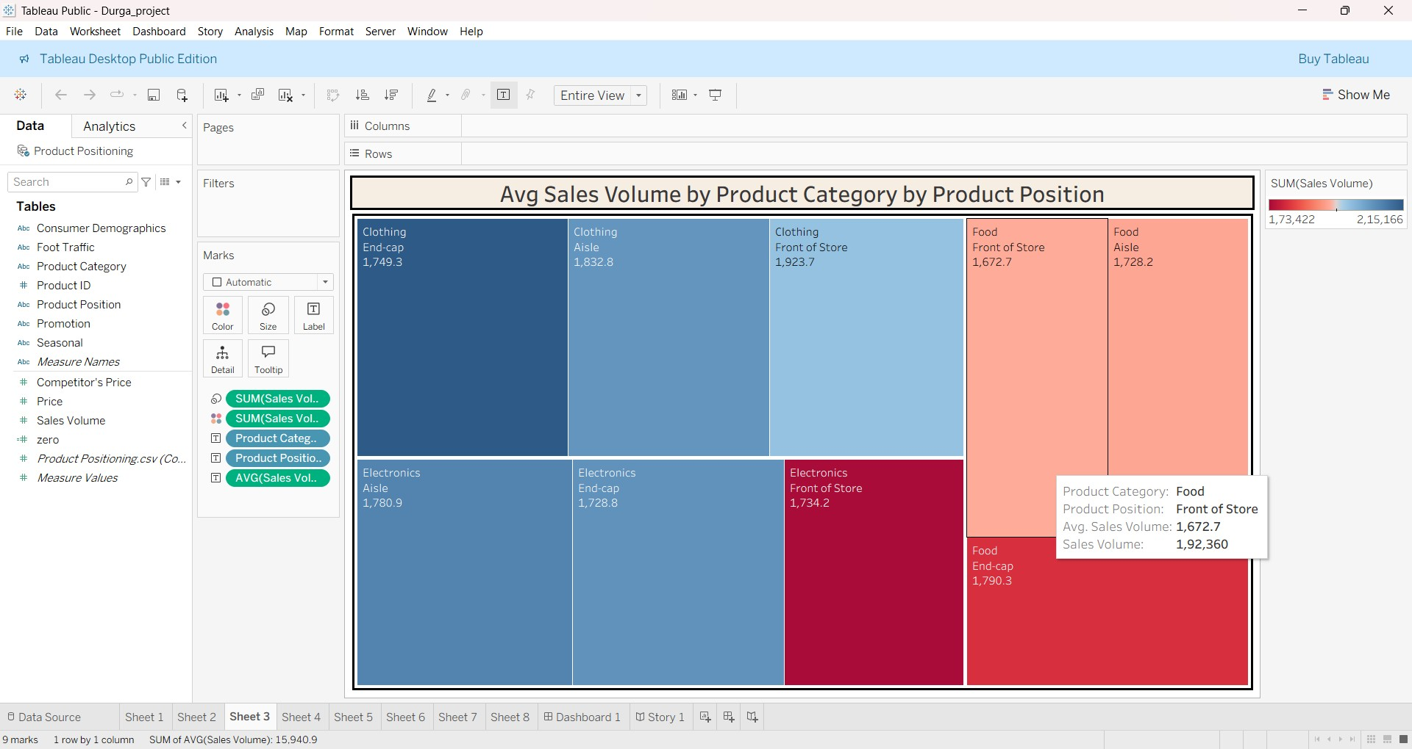

4.Consumer Demographics vs Sales Volume:

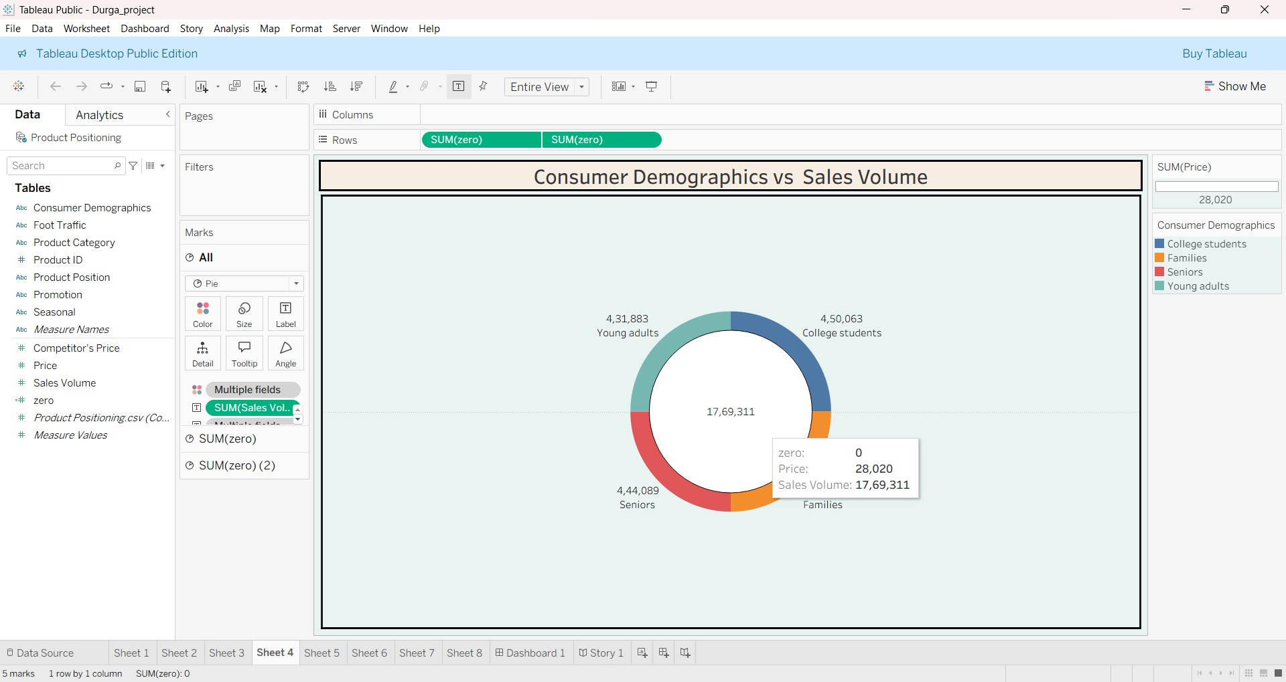

5.Product Category vs Price

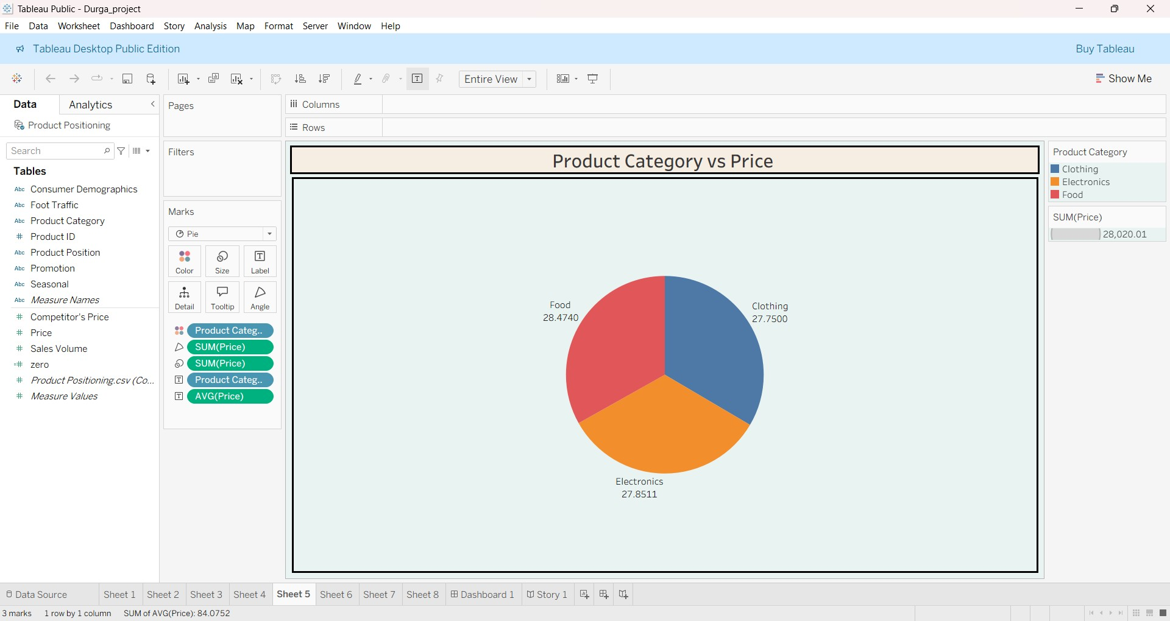

6.Avg Sales Volume by Product Category by Season:

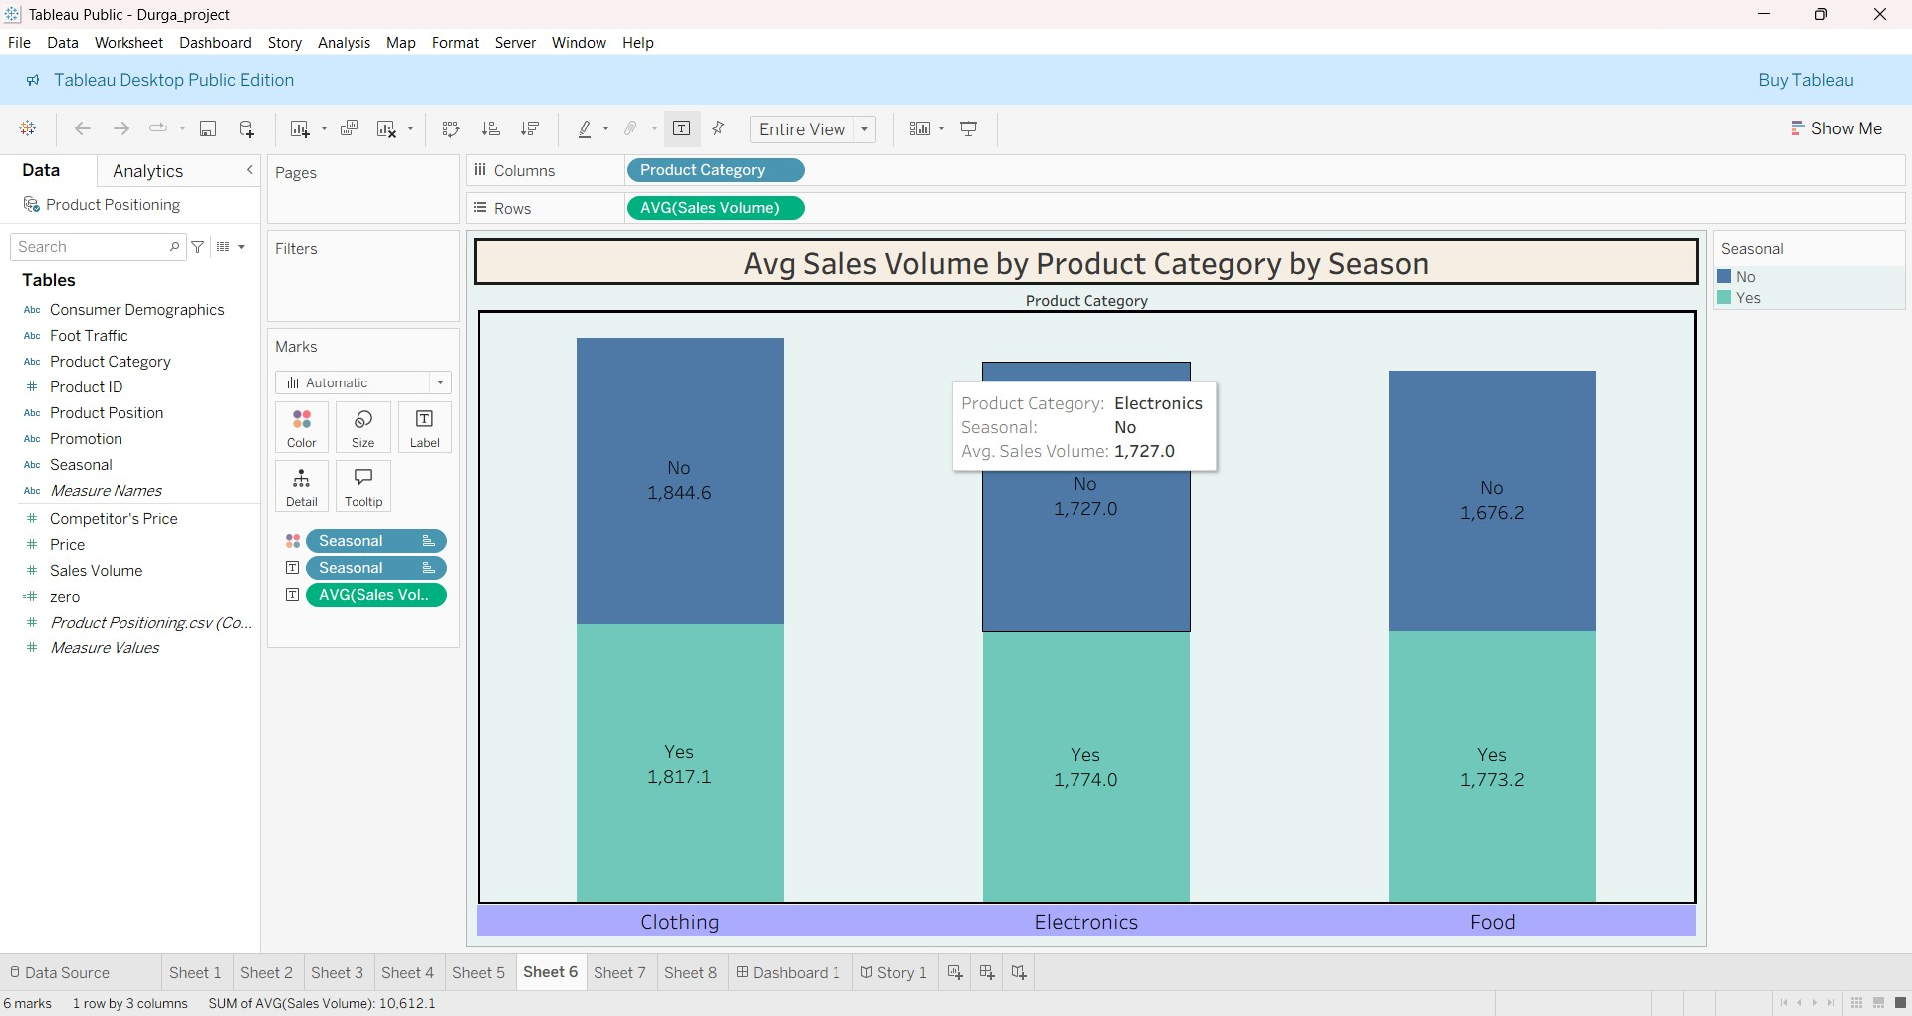

7.Foot Traffic by Avg Sales Volume:

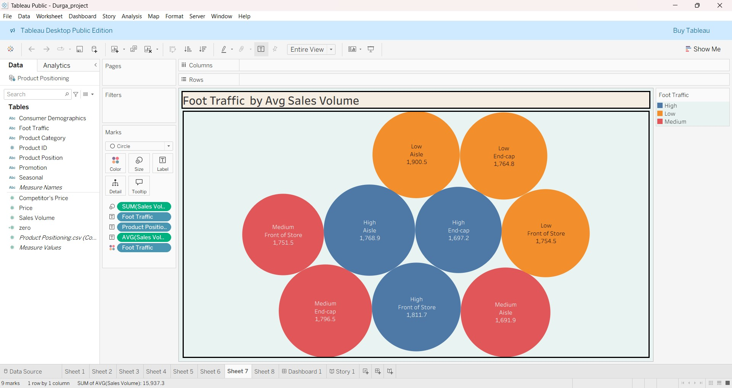

8.Promotion of Product Category on Price and Sales Volume:

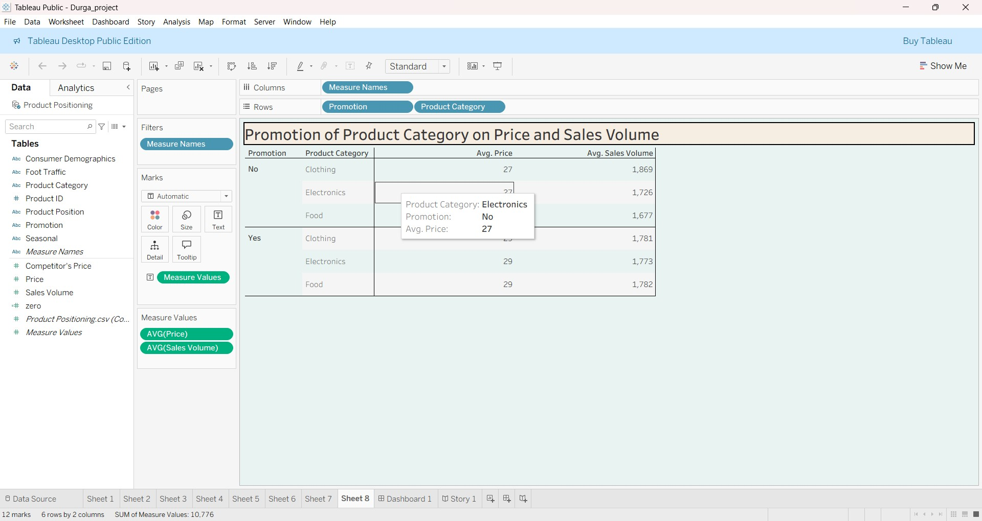

Avg Sales Volume vs Product Category

Avg Sales Volume by Product Category by Product

Position

Foot Traffic by Avg Sales Volume

Consumer

Demogra..

Product Cat..

0

200

400

600

800

1000

1200

1400

1600

1800

Avg. Sales Volume

Clothing

Electronics

Food

**1,830.1**

**1,748.6**

**1,727.7**

Product Category

Clothing

Electronics

Food

|  |  |  |  |
| --- | --- | --- | --- |
| Clothing  End-cap  1,749.3 | Clothing  Front of Store  1,923.7 | | Food  Front of Store  1,672.7 |
| Clothing  Aisle  1,832.8 |
| Food  Aisle  1,728.2 |
| Electronics  Aisle  1,780.9 |  | Electronics  Front of Store  1,734.2 |
| Food  End-cap  1,790.3 |
| Electronics  End-cap  1,728.8 | |

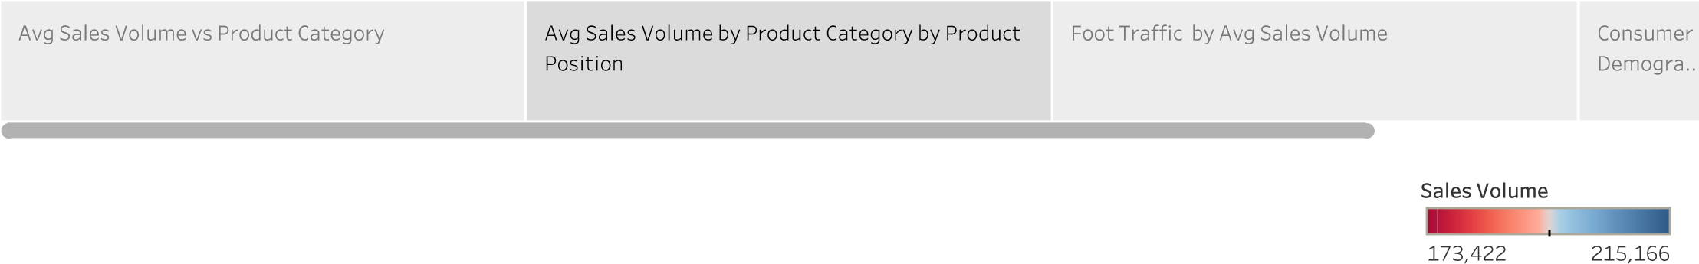

Avg Sales

Volume v..

Avg Sales Volume by Product Category by Product

Position

Foot Traffic by Avg Sales Volume

Consumer Demographics vs Sales Volume

Medium

Front of Store

1,751.5

Medium

End-cap

1,796.5

Medium

Aisle

1,691.9

Low

Front of Store

1,754.5

Low

End-cap

1,764.8

Low

Aisle

1,900.5

High

Front of Store

1,811.7

High

End-cap

1,697.2

High

Aisle

1,768.9

Foot Traffic

High

Low

Medium

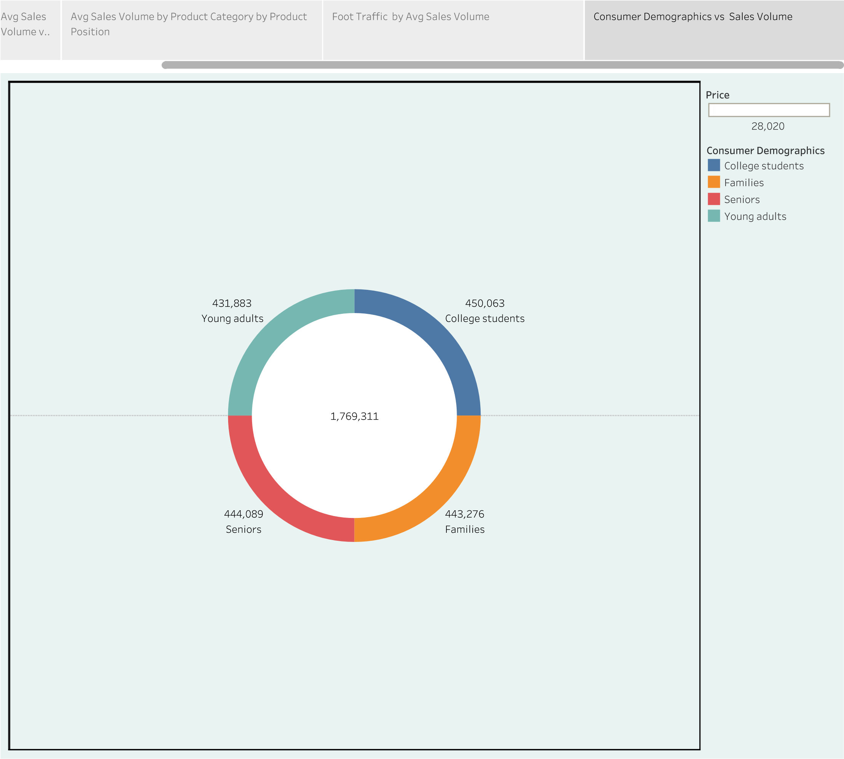

Project Development Phase Model Performance Test

|  |  |
| --- | --- |
| Date | 17 February 2026 |
| Team ID | LTVIP2026TMIDS87011 |
| Project Name | Strategic Product Placement Analysis |
| Maximum Marks | 5 marks |

**Model Performance Testing:**

Project team shall fill the following information in model performance testing template.

| **S.No** | **Parameter** | **Screenshot / Values** |
| --- | --- | --- |
| 1 | **Data Rendered** | Rendered from cleaned retail sales and product placement CSV datasets containing store-wise, region-wise, and placement-zone-wise transaction data. Dataset includes monthly, quarterly, and yearly sales records (1000+ transaction entries across multiple stores, categories, and placement zones). |
| 2 | **Data Preprocessing** | Handled missing/null sales values and removed duplicate transaction records. Standardized product categories, store names, placement zones (eye-level, end-cap, checkout, aisle). Created derived fields such as Year, Quarter, Seasonal Category, Placement Contribution %, and Profit Margin. |
| 3 | **Utilization of Filters** | Tableau filters applied for Store, Region, Product Category, Placement Zone, Year, Quarter, and Month. Interactive filtering enables dynamic analysis with response time under 3–5 seconds under normal data volume. |
| 4 | **Calculated Fields Used** | • Year-over-Year (YoY) Sales Growth  • Placement Contribution Percentage  • Profit Margin Calculation  • Monthly & Quarterly Sales Aggregation  • Store-wise Revenue Comparison  • Top & Bottom Performing Placement Zones  • KPI Metrics (Total Sales, Total Profit, Highest Performing Zone, Category Share %) |
| 5 | **Dashboard Design** | Multiple visualizations designed to present strategic product placement insights, including:  • Placement Zone Performance Bar Chart  • Store-wise Sales Comparison  • Monthly Trend Line Chart  • Category Contribution Chart  • Top & Bottom Performing Products  • Year Comparison (YoY Sales Analysis)  • Placement Heat Map |
| 6 | **Story Design** | One Tableau Story created with sequential story points highlighting:  • Retail Sales Overview  • Placement Zone Effectiveness Analysis  • Store & Regional Performance Comparison  • Seasonal Sales Trends  • Strategic Recommendations for Layout Optimization |
| 7 | **Publishing and Web Integration** | Dashboard and story published to Tableau Public / Tableau Server and embedded into a web interface using Tableau embed code.  • Hosted on web platform (HTML, CSS, JavaScript)  • Interactive filters functional online  • Responsive layout for laptop/projector presentation • Shareable public link for stakeholder access • Real-time dashboard interaction via browser |

|  |  |
| --- | --- |
| Date | 17 February 2026 |
| Team ID | LTVIP2026TMIDS87011 |
| Project Name | Strategic Product Placement Analysis |
| Maximum Marks |  |

**PROJECT REPORT**

**Strategic Product Placement Analysis**

**1. INTRODUCTION**

**1.1 Background**

In today’s competitive retail environment, product placement plays a crucial role in influencing customer purchasing behavior and maximizing sales performance. Retail stores generate massive volumes of transactional data across multiple locations, categories, and shelf positions. However, much of this data remains underutilized due to its scattered structure in spreadsheets and POS systems.

Retail managers, category heads, and merchandising teams require clear insights into how product positioning (eye-level shelves, end-cap displays, checkout counters, promotional zones) impacts revenue and profitability. Without interactive analytics tools, analyzing these patterns becomes time-consuming and inefficient.

Data visualization tools such as Tableau transform raw retail sales and placement data into interactive dashboards, enabling stakeholders to monitor trends, compare store performance, identify high-performing placement zones, and make data-driven merchandising decisions.

**1.2 Project Overview**

Strategic Product Placement Analysis is a Tableau-based data visualization project designed to analyze and present retail sales performance based on product placement strategies across stores and time periods.

This project focuses on:

Store-wise sales distribution

Placement zone performance comparison

Monthly and quarterly sales trends

Identification of high-performing and underperforming shelf areas

Year-over-Year (YoY) sales comparison

Interactive storytelling using Tableau Story

The dashboard converts raw CSV retail datasets into actionable visual insights that support strategic merchandising decisions.

**1.3 Objectives**

The main objectives of this project are:

To design an interactive product placement analytics dashboard

To analyze sales performance across stores and placement zones

To identify seasonal and peak sales periods

To compare Year-over-Year sales growth

To present insights using story-based visualization

To publish dashboards for web accessibility

**2. IDEATION PHASE**

**2.1 Problem Statement**

Retail organizations often lack a centralized, interactive platform to analyze how product placement impacts sales performance. Sales data stored in static Excel sheets limits the ability to identify trends, evaluate shelf effectiveness, and optimize store layouts. This creates inefficiencies in merchandising decisions and revenue planning.

**2.2 Target Users**

The primary users of this dashboard include:

Retail Managers

Merchandising Teams

Category Managers

Marketing & Promotions Analysts

Senior Executives

**2.3 Empathy Map**



**Data driven decision making for future planning**

**THINK & FEEL**

Concerned about declining sales in certain categories

Unsure whether shelf placement affects product visibility

Feels pressure to improve store revenue

Wants clear, reliable data for decision-making

Aspires to optimize layout for better customer experience

**HEAR**

Management demanding revenue growth

Customers responding to promotional displays

Marketing teams discussing campaign performance

Competitors adopting smarter merchandising strategies

* **SEE**

Uneven sales performance across stores

Seasonal demand spikes

Underutilized shelf spaces

High sales from promotional or eye-level displays

**SAY & DO**

Reviews sales dashboards regularly

Conducts merchandising meetings

Discusses layout optimization strategies

Plans promotional placement changes

**PAIN (Fears & Frictions)**

Poor visibility of product performance by placement

Scattered sales data

Ineffective shelf utilization

Difficulty identifying underperforming zones

**GAIN (Needs & Success Measures)**

Clear visualization of placement effectiveness

Ability to compare stores and time periods

Data-backed layout optimization

Improved revenue and profitability

Faster decision-making

**3. REQUIREMENT ANALYSIS**

**3.1 Functional Requirements**

Interactive filters (Store, Region, Category, Placement Zone, Year, Quarter)

Placement zone performance charts

Monthly & quarterly sales trend analysis

Year comparison visuals (YoY growth)

Story-based dashboard navigation

KPI summary indicators (Sales, Profit, Growth %)

**3.2 Non-Functional Requirements**

* Dashboard loading time under 5 seconds
* Responsive layout for executive presentations
* Accurate KPI calculations
* Secure publishing via Tableau Server/Public
* Scalable data structure for future expansion

**3.3 Data Requirements**

The dashboard uses retail sales and placement datasets containing:

Store Name

Region

Product Category

Placement Zone

Monthly Sales

Quarterly Totals

Year (e.g., 2022 & 2023)

Total Records: 1000+ entries

**4. SYSTEM DESIGN**

**4.1 Data Flow Diagram**

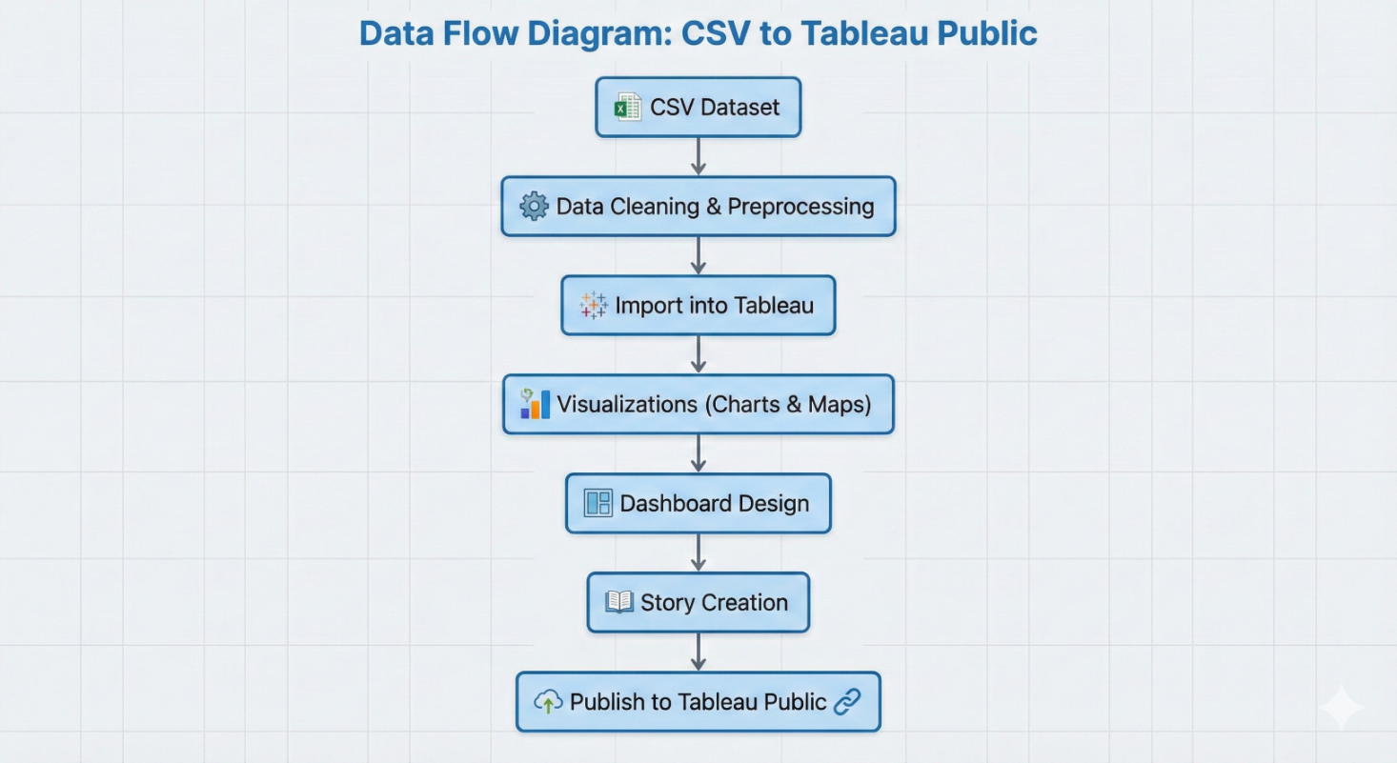

**4.2 Solution Architecture**

**User Interface Layer**

Tableau Web Dashboard

Interactive filters and KPI cards

**Application Layer**

Tableau Calculated Fields

Filtering, aggregation, and business logic

**Data Layer**

CSV retail datasets

Optional cloud storage

**Deployment Layer**

* Tableau Public / Tableau Server
* Embedded via HTML iframe

**5. PROJECT PLANNING & SCHEDULING**

| **Phase** | **Task** | **Time (Days)** |
| --- | --- | --- |
| Phase-1 | Data Collection | 1 |
| Phase-2 | Data Cleaning & Preprocessing | 2 |
| Phase-3 | Visualizations Development | 2 |
| Phase-4 | Dashboard & Story Creation | 2 |
| Phase-5 | Performance Testing | 1 |
| Phase-6 | Web Integration & Publishing | 1 |
| Phase-7 | Report & Documentation | 3 |

**6. FUNCTIONAL AND PERFORMANCE TESTING**

**6.1 Performance Testing**

Data Loaded: 1000+ retail records

Filters Used: Store, Region, Category, Placement Zone, Year, Quarter

Calculated Fields: YoY Growth, Placement Contribution %, Profit Margin

Visualizations: 12–15

Result: Smooth performance with response time under 3–5 seconds

**7. RESULTS**

**Output Screenshots (Examples)**

**Avg Sales Volume vs Product Category**



**Avg Sales Volume vs Product Category:**

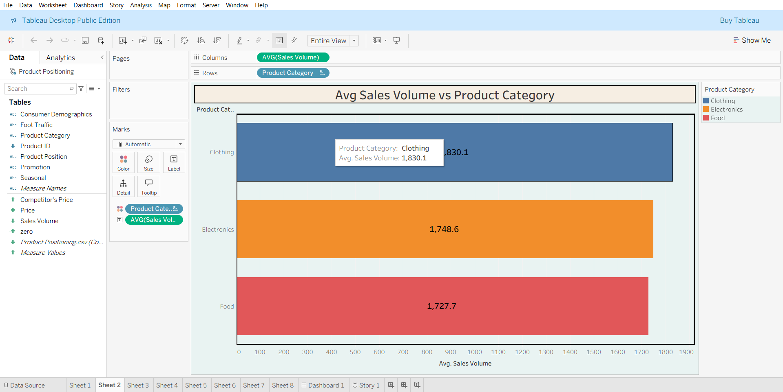

**Product Category vs Price**

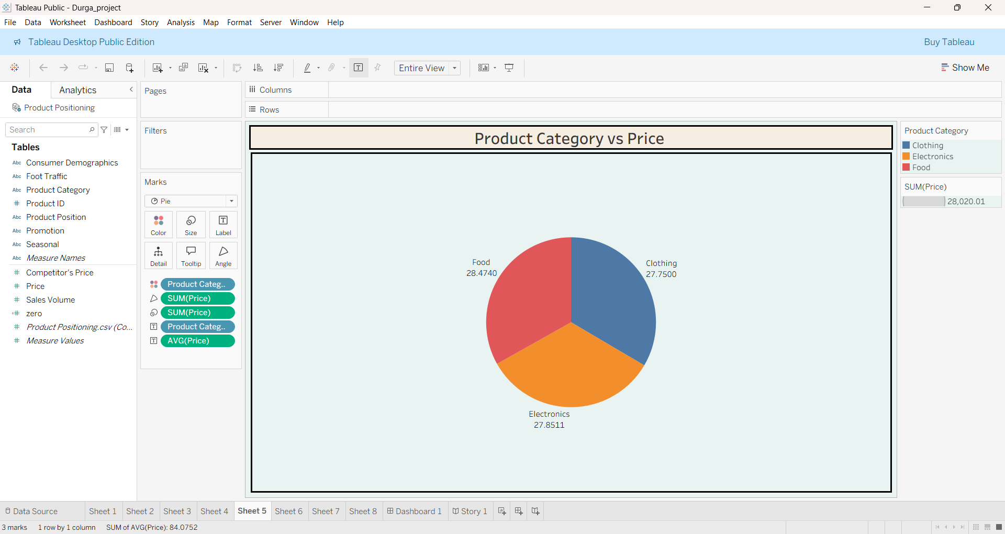

**Consumer Demographics vs Sales Volume**

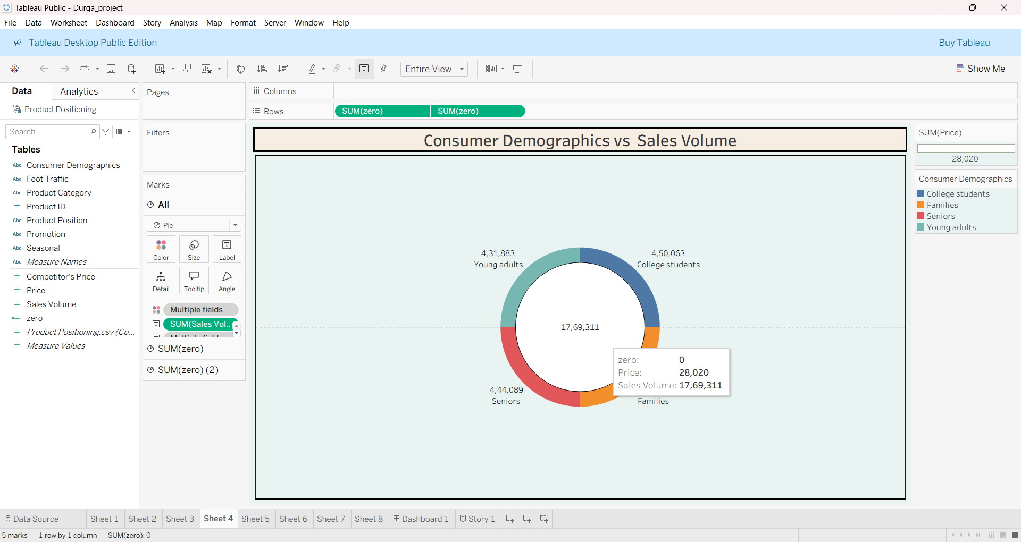

**Foot Traffic by Avg Sales Volume**

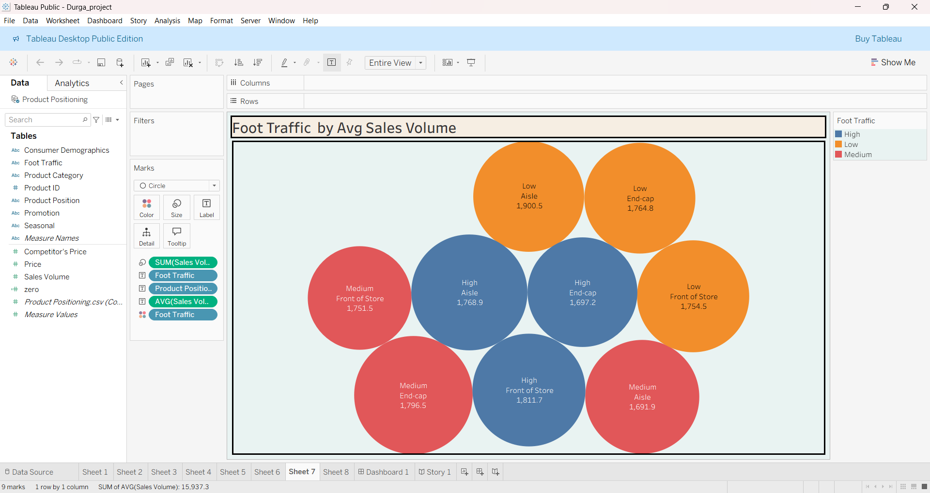

* **Dashboard**

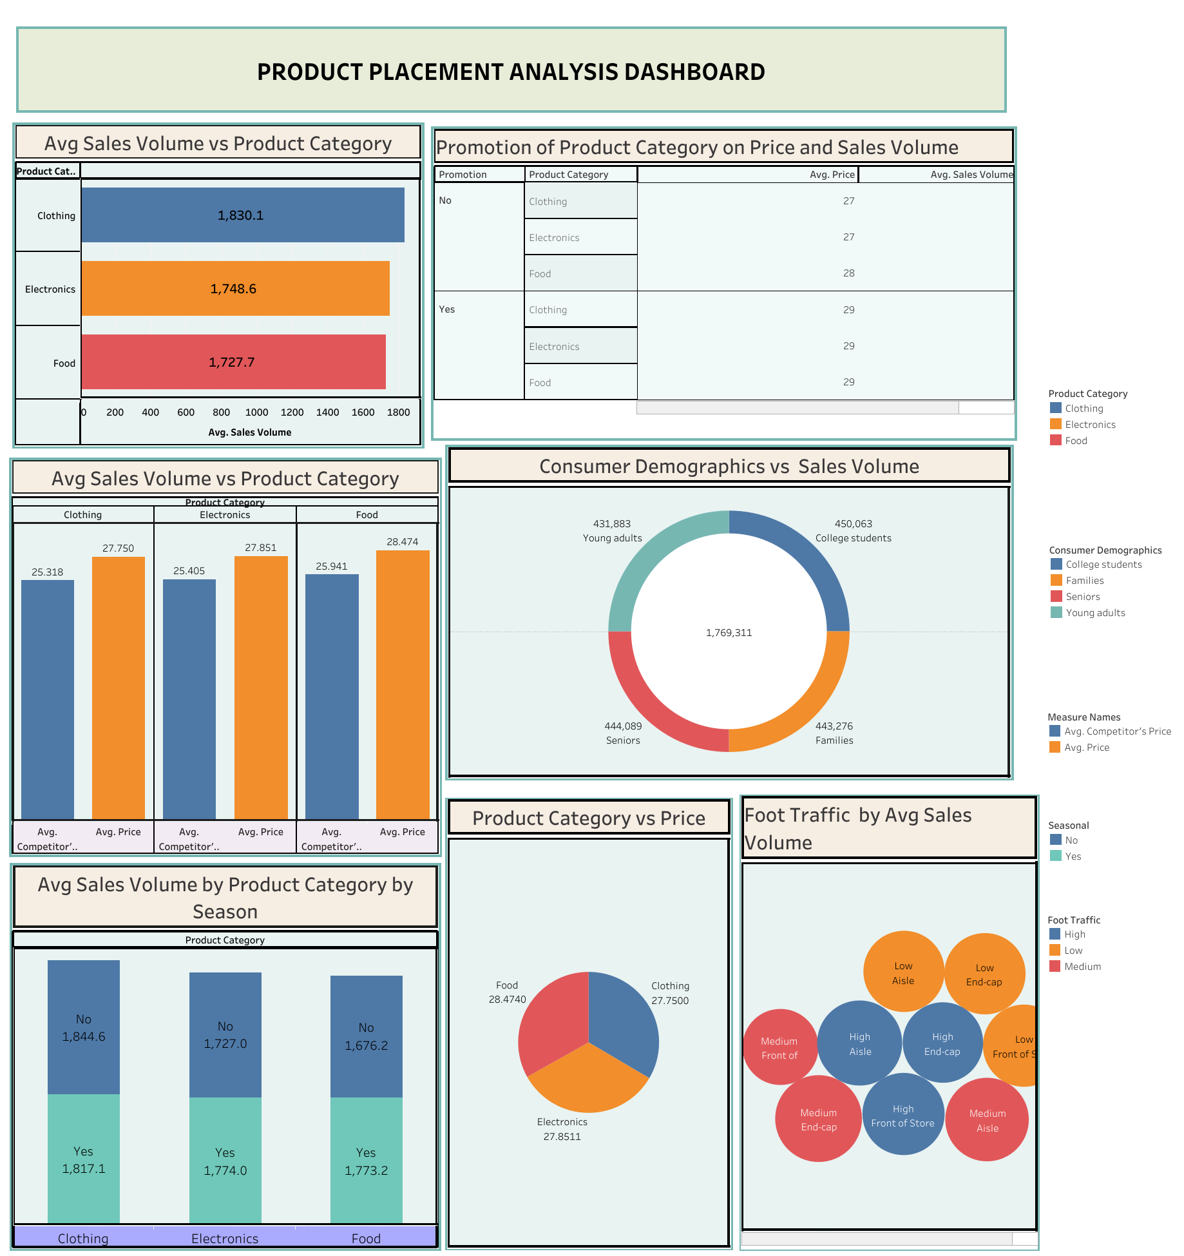

**Story**

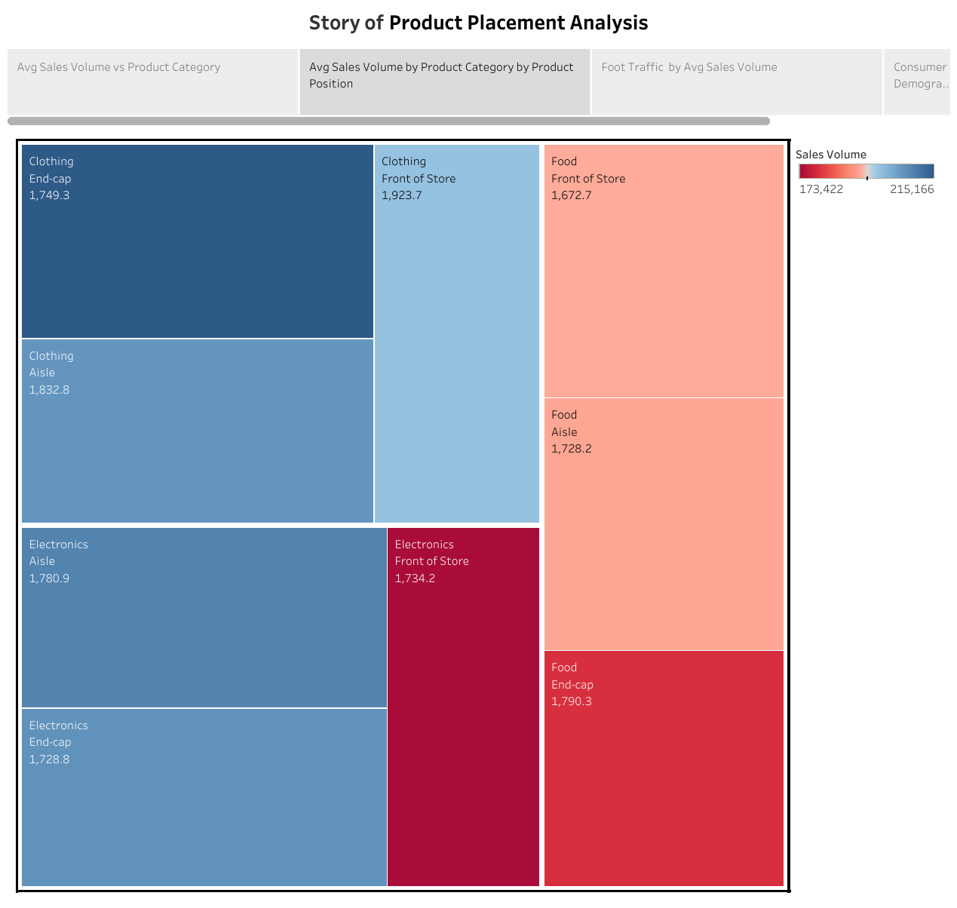

**8. ADVANTAGES & DISADVANTAGES**

* **Advantages**

Easy interpretation of placement performance

Centralized retail analytics

Interactive and story-driven presentation

Supports data-driven merchandising decisions

Improves revenue optimization

* **Disadvantages**

Requires Tableau knowledge

Uses static datasets (if no live POS integration)

Scalability may require cloud infrastructure

**9. CONCLUSION**

This project demonstrates how Tableau can transform raw retail sales and placement data into meaningful business insights. The dashboard simplifies complex datasets into interactive analytics, enabling stakeholders to monitor sales trends, evaluate shelf effectiveness, and optimize product placement strategies for maximum profitability.

**10. FUTURE SCOPE**

Integrate real-time POS data

Implement predictive sales forecasting models

Add AI-based placement recommendation system

Develop mobile-friendly dashboards

Expand analytics to customer behavior and basket analysis

**11. APPENDIX**

**Data set Link: -** CSV file used in Tableau

[https://drive.google.com/file/d/1vHDNGw130kbYUPj-wl4640x-cz5349GM/view?usp=sharing](fontTable.xml)

**Tableau Publish: -**

* **Dashboard:**

[https://public.tableau.com/views/PRODUCTPLACEMENTANALYSISDashboard/Dashboard1?:language=en-US&:sid=&:redirect=auth&:display_count=n&:origin=viz_share_link](theme/theme1.xml)

* **Story**

<https://public.tableau.com/shared/YK7C5X965?:display_count=n&:origin=viz_share_link>

**Project Demo: -**

<https://drive.google.com/file/d/1WYIUXBAlYbYGTUcm2jy5qtBJAD4M9_Wf/view?usp=drivesdk>